Name: Priyanka

Mail Id: [priyankabaskar7797@gmail.com](mailto:priyankabaskar7797@gmail.com)

Task: Install docker on EC2 and explore the docker commands (docker images, containers, volumes, network)

1. Pushing Docker images:

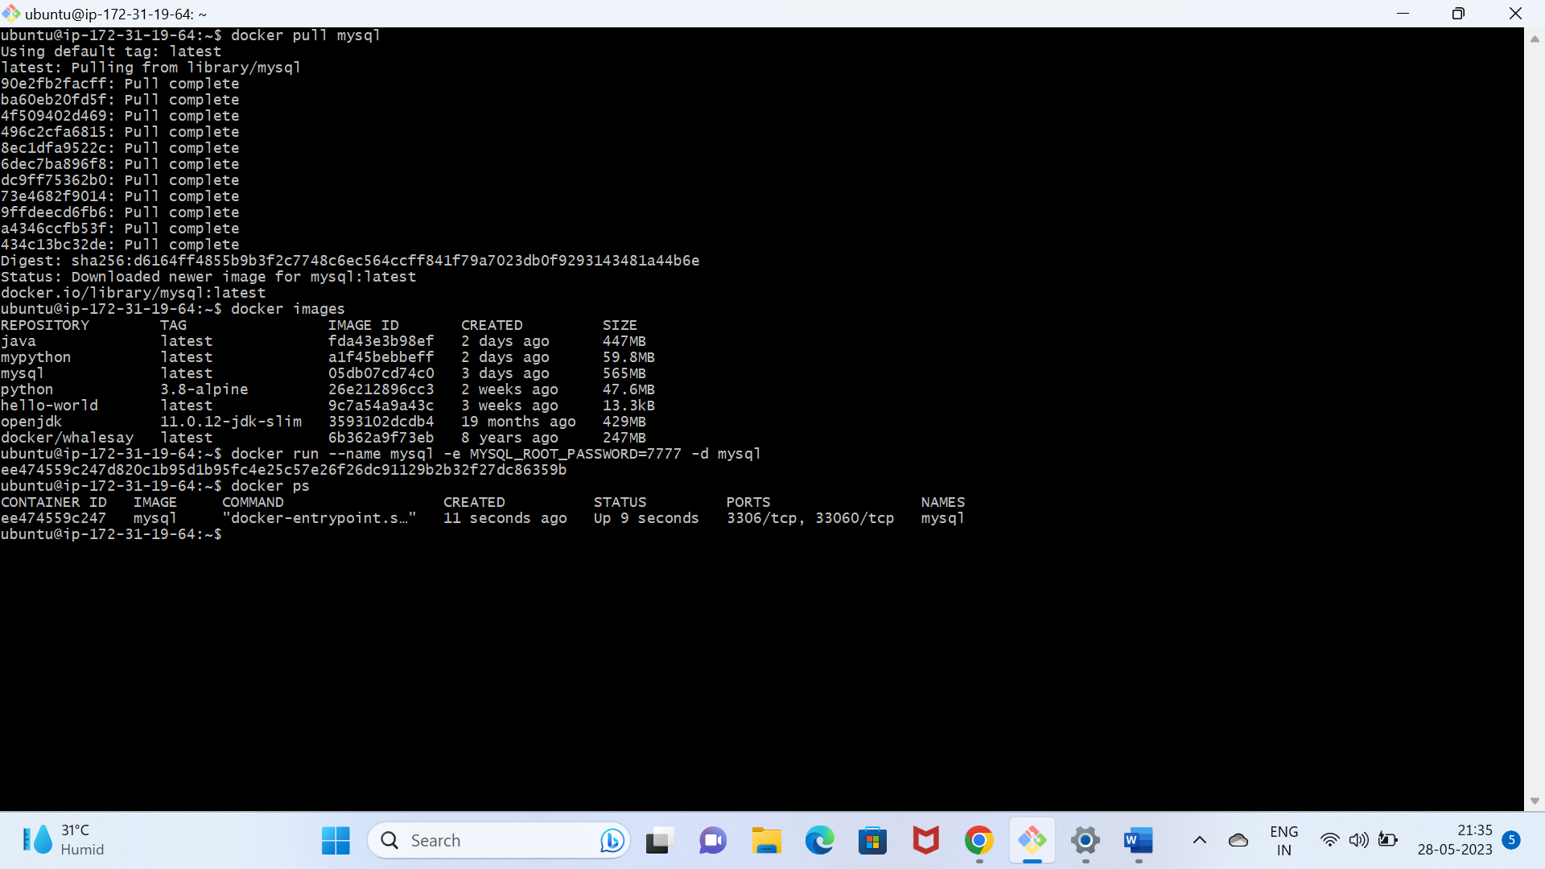

1. Creating container:

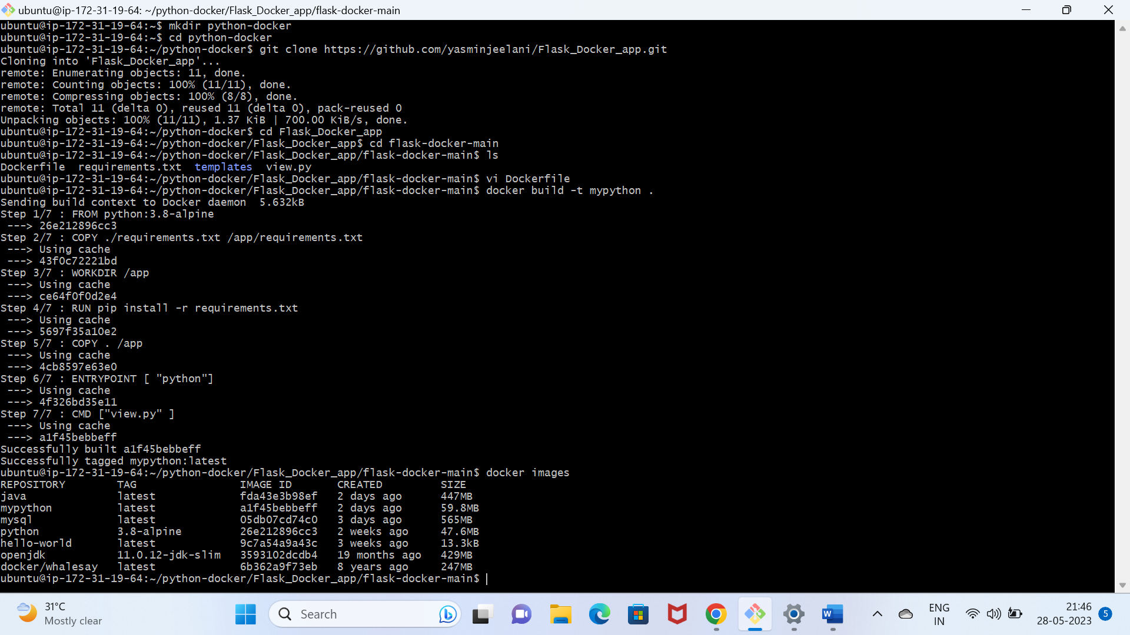

1. Installing mysql image and container:

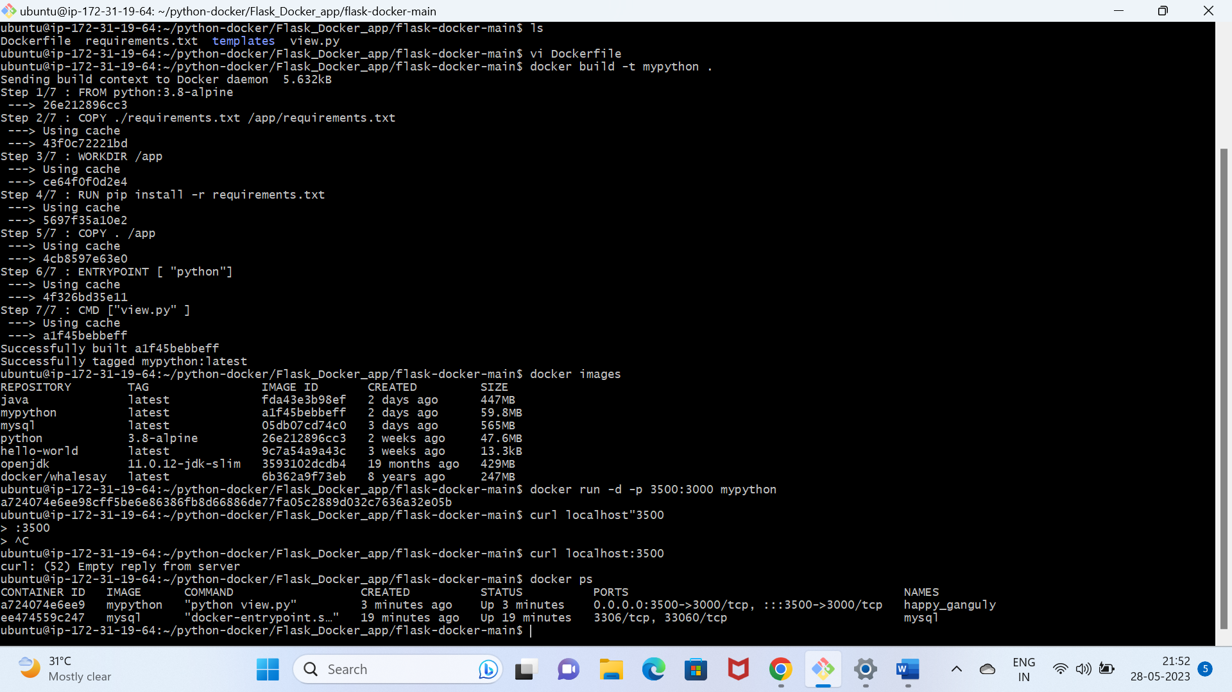

1. Pushing Docker image:

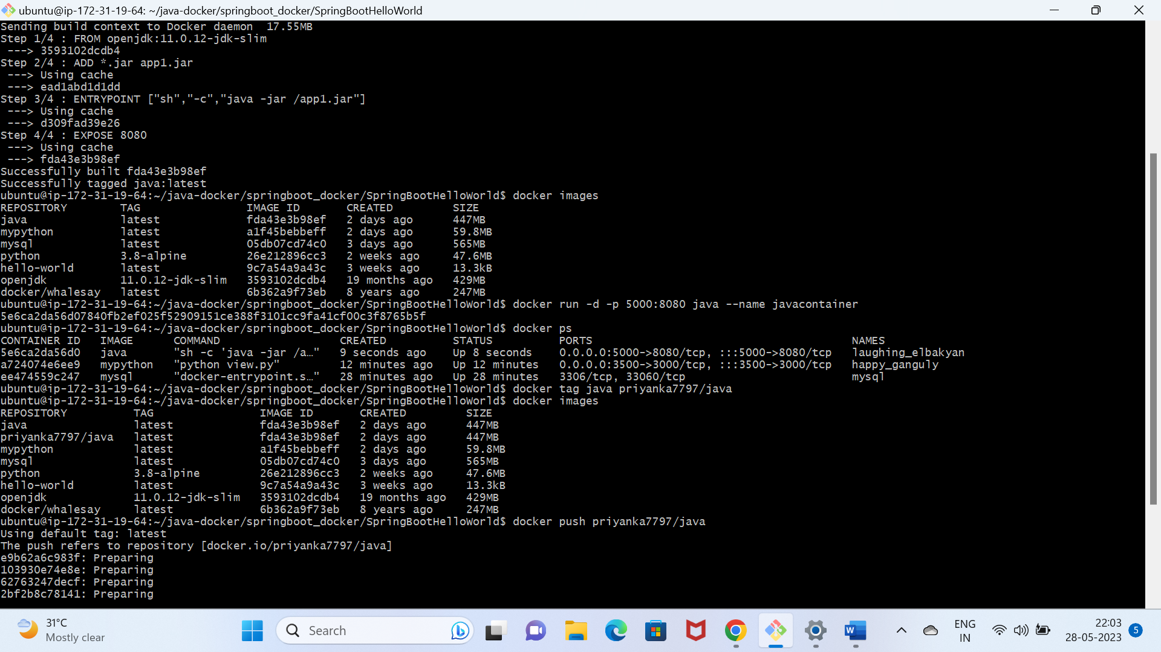

1. Creating volume:

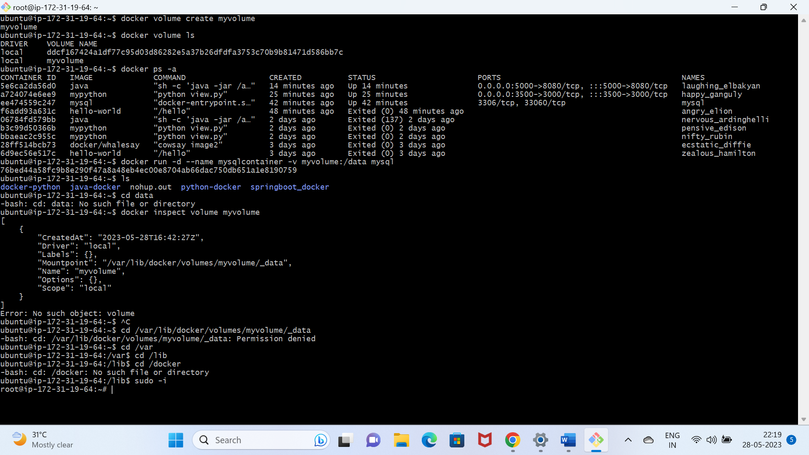

1. Running volumes:

